LAB 5
Spring 2011, BESE- 15
Using Databases with asp.net

OBJECTIVE

This lab has the objective to familiarize students with:
- Introduction to databases.
- Introduction to ASP.net database controls.

Submission Requirements:
This is a practice session and you do not need to submit any code.

TASK:
- Star visual studio and create a new website with C# as the language selected.
- Copy the given Database.mdf file into the App_Data folder of your website.
- Open the server explorer, select the database name and Refresh it. Once refreshed it is connected.
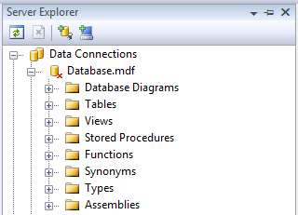

- Add a SQLDataSource control to the webpage. Connect it to the database and set the properties.
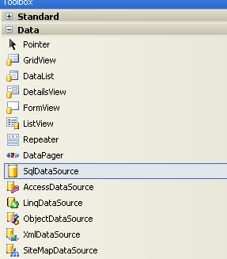

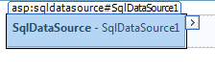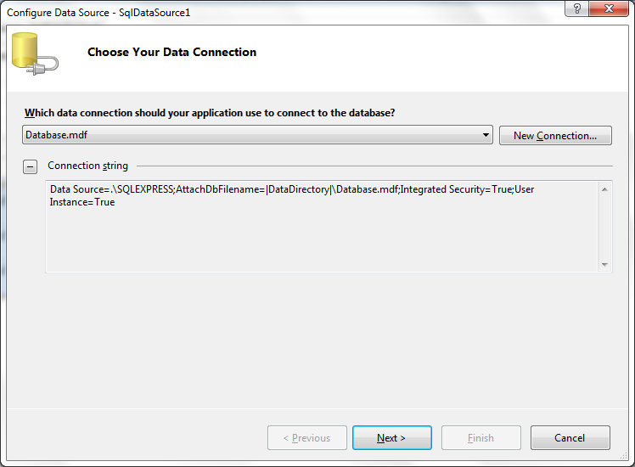

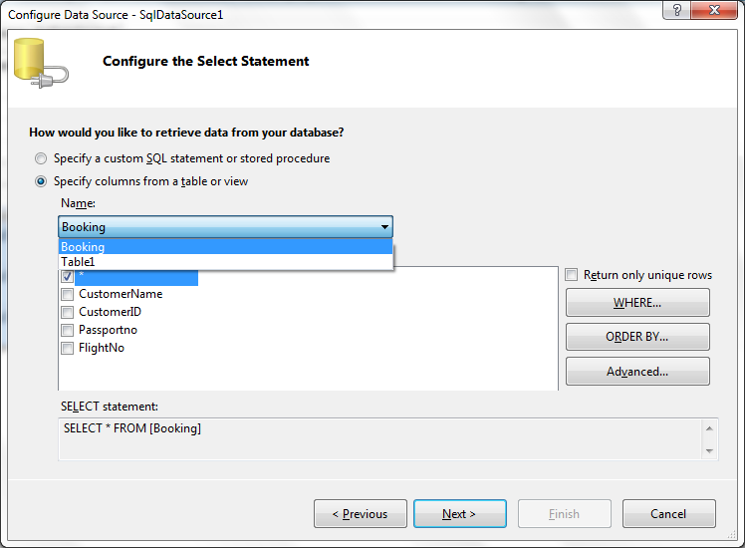

- On the webpage add a GRIDVIEW control.
- Bind the GRIDVIEW control to SQLDataSource1.
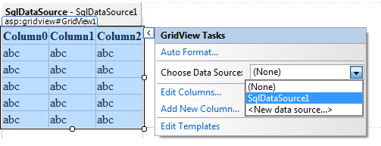
- Enable Editing, Deleting and Selecting for the GRIDVIEW.
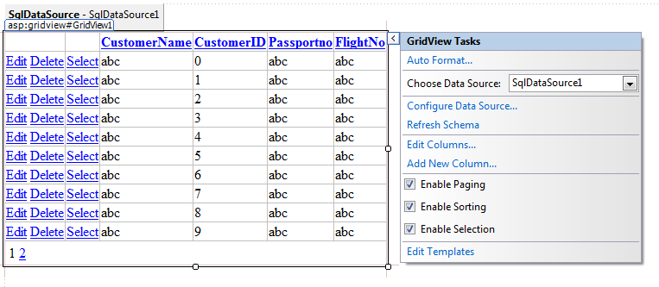
- Filter records that it displays data only where customer id is 2.
HINT: Configure DataSource. Change the query and add the ‘Where’ clause options.

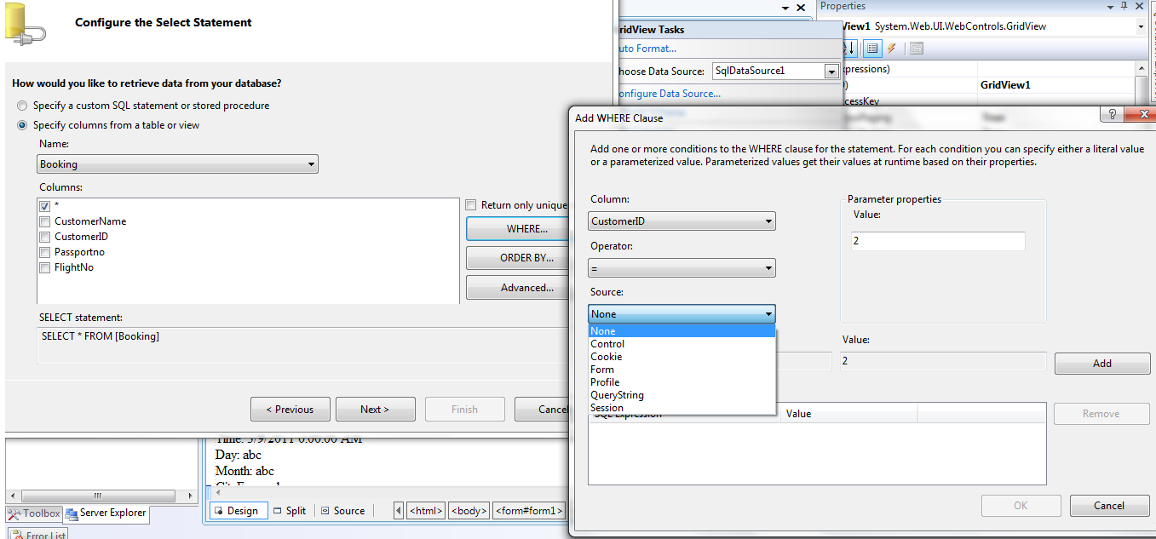

- Add FormView control and DetailsView Control in the similar fashion and set their properties.
- Remove the effect of step 8.
- Link the DetailsView to the already added GridView such that when a record is selected in GridView, the respective detail of flight is opened in DetailsView.
HINT: Configure Data Source. Change query and add the ‘Where’ clause options.
In the GridView’s properties select ‘FlightNo’ as the ‘DataKeyNames’.
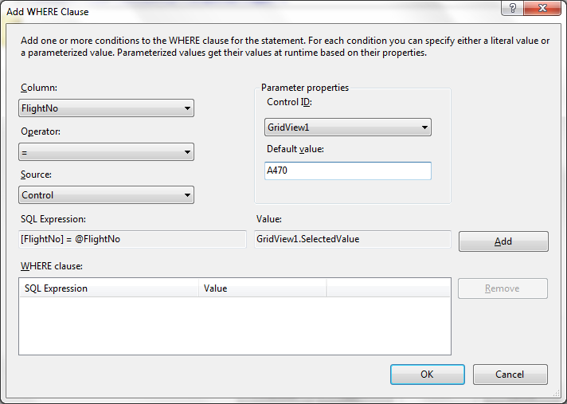

Now create a database of your own about a college (student enrollment in courses only) and display the data in it.
Student (SID, Name, Address, ContactNo)
Course (CCode, CName, CreditHours)
StudentCourse (SrNo, SID, CCode)
- Select ‘Add New Item’ and chose a ‘SQL Server Database’.

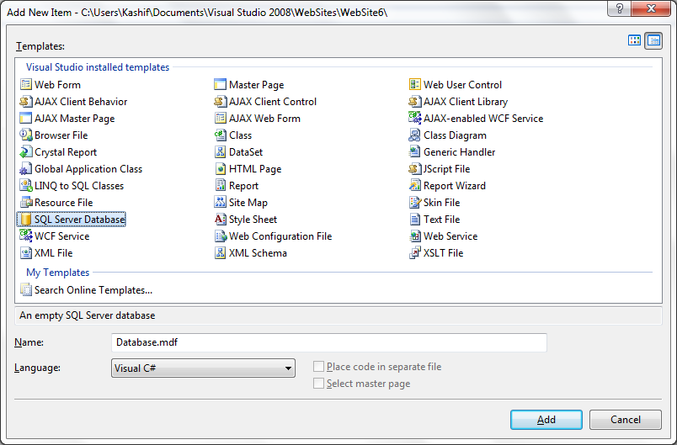

- Add it to App_Data folder.
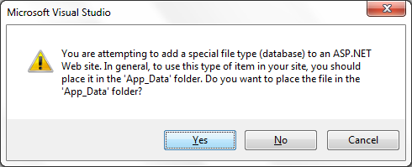

- Once the database is added, create new tables.
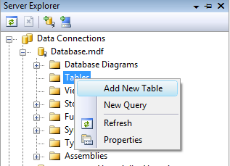

- Add data to the tables.
